What is data ?

It is a raw fact ,that can be characters (or) numbers(or) symbols..etc

Data will not give a meaningful statement

Eg: pavan is a data

Anand is a data

Charan is a data

1000 is a data

2000 is a data

10000 is a data

What is information ?

Processing rawfact / data is called as information.

It always provide meaning full statement . here there are not just data. Pavan is the name of the customer , which has some specific meaning . so this can be said as the information.

Eg: customer_name

Pavan

Anand

Charan

Similarly 1000 is the customer id, which has some specific meaning , so this can be said as the information.

Customer_Id

1000

2000

10000

A student secures 450 marks. Here 450 is **data**, marks of the student is the **information**

What is Database ?

It is a organized collection of structured information or data stored electronically in the a computer system. A database is usually controlled by a database management system . together Data and the DBMS along with the applications associated with them is called database systems (or) often said as database.

Data Base Management System ( DBMS ) :

DBMS is a Software that stores and manages large amount of data . DBMS software gave a structured way / well organized way to store the. Here data is stored in a file . and no relationship between data . it deals with small quantity of data.

Initially DBMS is maintained individually to store data . later there is a need to connect the database to software

The software developed using a programming language is connected with the DBMS.

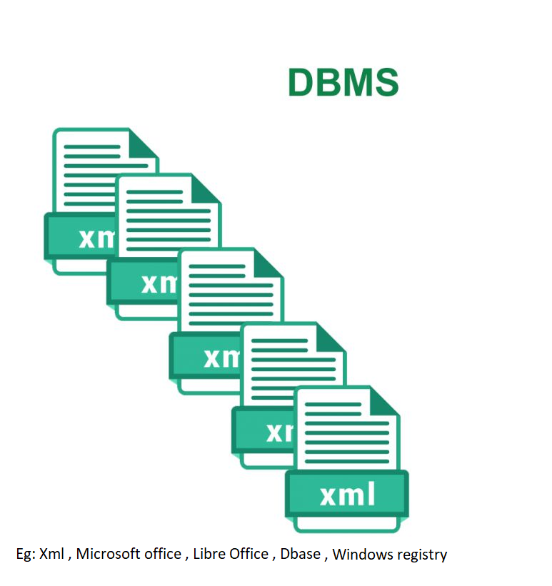

Types of DBMS

1. Hierarchical DBMS
2. Network DBMS
3. Relational DBMS
4. Object Oriented DBMS
5. Hierarchical DBMS :

Here data is organized in a tree like structure . Data is stored in top – bottom ( or) bottom up format and is represented using a parent child relationship.

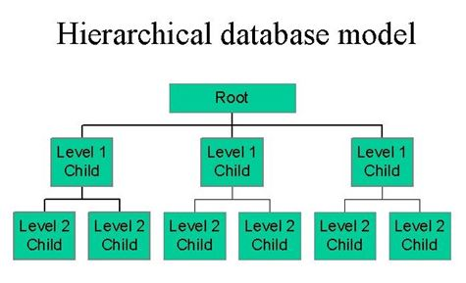

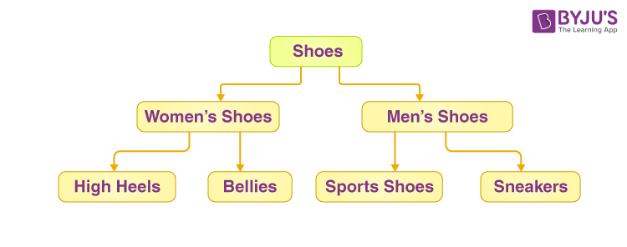

1. Network DBMS :

It is similar to hierarchical DBMS but address some more complex relationships by allowing each child to have multiple parents .

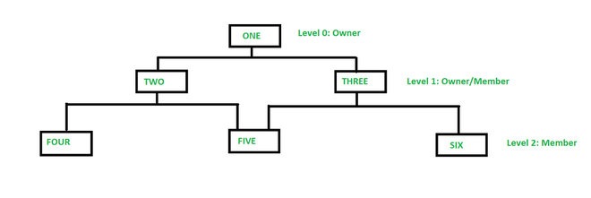

1. Relational DBMS

In Relational DBMS the data is stored in tabular format as rows and columns , operations like create, insert, update , delete etc.. are performed on them.

Maintaining a large amount of data in a single table is not so easy

Eg: consider a passport of a person it has a lot of information like , address , mobile number ,

Face id , parents name, nationality , gender , Iris data , passport validity etc . maintaining a lot of information in a single table is difficult to maintain sometimes

To solve this problem we use RDBMS (Relational Database Management System)

Here information is stored in multiple tables and all the tables are connected .

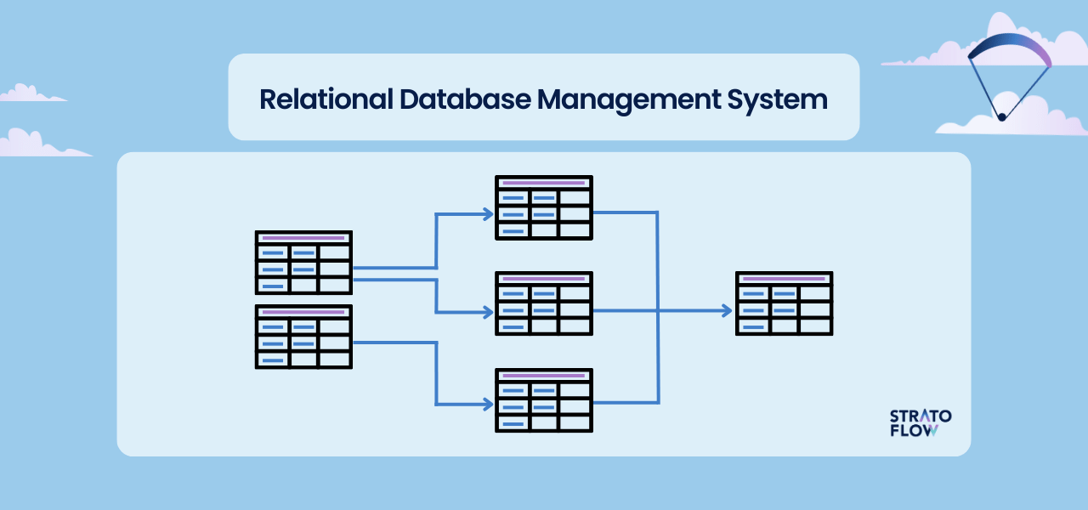

Some of the popular RDBMS are

My SQL

PostgreSQL

Oracle Server

SQL Lite

MariaDB

RDBMS databases are also called as SQL databases.

Here the data is stored in table as rows and columns.

|  |  |  |  |  |
| --- | --- | --- | --- | --- |
|  |  |  |  |  |
|  |  |  |  |  |
|  |  |  |  |  |

Each row is called as a record ( green coloured portion ) .

Recommended Naming Conventions

For Database names , table names variable names it is recommended to use lower case

For SQL commands , clauses , constrains which are predefined in SQL ,that is recommended to use in upper case.

Note : Some RDMS use “ ; ” at the end of the statement , and some doesn’t use semicolon , so better learn by writing semicolon at the end of the statement .

1. Object Oriented DBMS :

Object oriented models store data in the form of objects instead of rows and columns. It is based on object oriented programming consists of classes, objects, properties / fields , methods. And supports the oops concepts like polymorphism ,abstraction , inheritance, Encapsulation.

Eg: db4o , Zope Object Database ( ZODB) , ObjectDB , Versant Object database

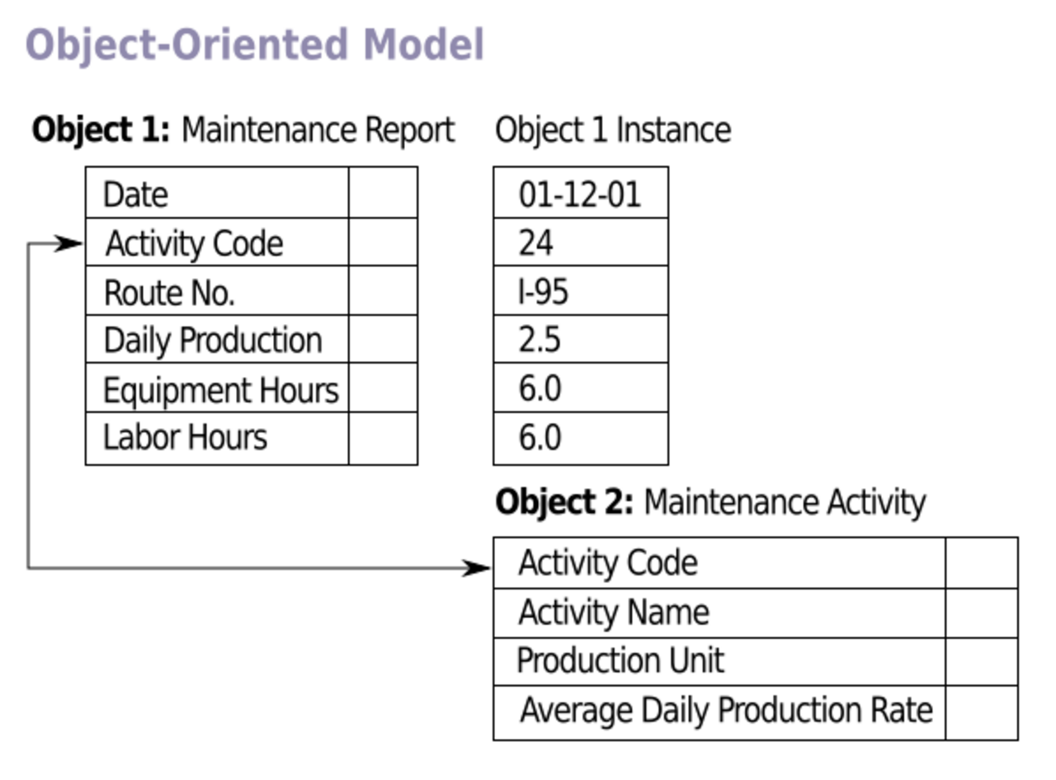

Are NO-SQL Databases same as Object Oriented databases ?

Some NoSQL databases (those using a document model) are similar but not the same thing as object-oriented databases.

NoSQL Databases

When you are dealing with bulk data processing then it is not recommended to store the data in the rows and columns , then we should go with NoSQL

Some of the NoSQL databases are

MongoDB

Cassandra

Hbase

In NoSQL Databases the data is stored in the form of key – value pair, Graphs , Documents etc

Here data is not stored in a structured way. To perform operations in these databases , they doesn’t have a common language like SQL , each database have their own language and methodology .

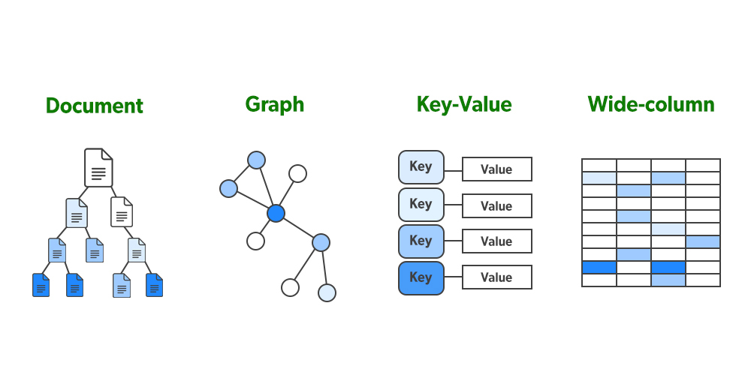

Types of database systems

1. OLTP ( online transaction processing )
2. OLAP ( online analytical processing )

OLTP :

It is a system that manages the transaction oriented applications , they are used to store day -day transactional information .

Every industry in today world oltp system to record transactional data . the main concern of otlp systems to enter, store and retrieve data. That covers all day to day operations such as

Purchasing , manufacturing, payroll , accounting etc of an organization . The data acquired by an oltp system is stored in an RDBMS

Eg: Oracle , Mysql , Sql server , Sybase etc ..

Advantages of oltp :

It allows its user to perform operations like read, write and delete data quickly

It responds to its user actions immediately and process the data very quickly

OLAP :

These systems are used for storing “historical data / large data / big data “ . With that data they make reports ,data visualizations ( gaphs , piexharts , bargraphs etc ) , data analysis .

Based on this data the organization can make some decisions , future plans

One of the tool for olap is Datawarehouse

In olap we can perform only select ( reading the data ) operation , but we cannot perform insert, update , delete operations ( write operations ) .

Olap is used only for storage purpose and reading purpose . but oltp operations cannot be performed on olap.

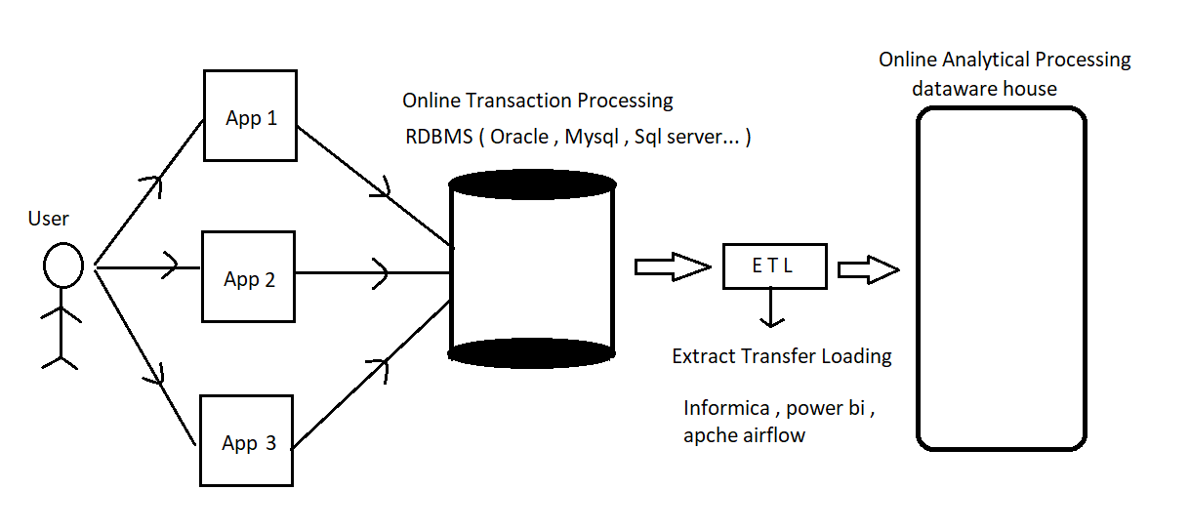

Realtime usage of OLTP and OLAP :

Eg : the user may use different applications to make the transactions . the transactional data acquired by OLTP is stored in an Relational data base management systems like oracle .

All the day to day transactional data is stored in RDBMS . OLTP is connected to OLAP by ETL Tool ( informica , powerbi , apache airflow ) .

Hourly basis , daily basis , monthly basis according to the requirement the data from RDBMS is sent to the OLAP data ware house , so that OLTP database space will be free , and it will be available for new data. When the ware houses are full they are replaced with other warehouse

Eg: IRCTC bookings through internet is available from 00:20 AM to 11:45 PM in this time 35 min the bookings will not be taken . here in this mean time the data is transferred from OLTP to OLAP .